# Programming the BLE_Sensor_Node

## SmartRF06 and BLE_Sensor Setup

### SmartRF06 Eval board overview

The SmartRF06 Eval board looks like this:

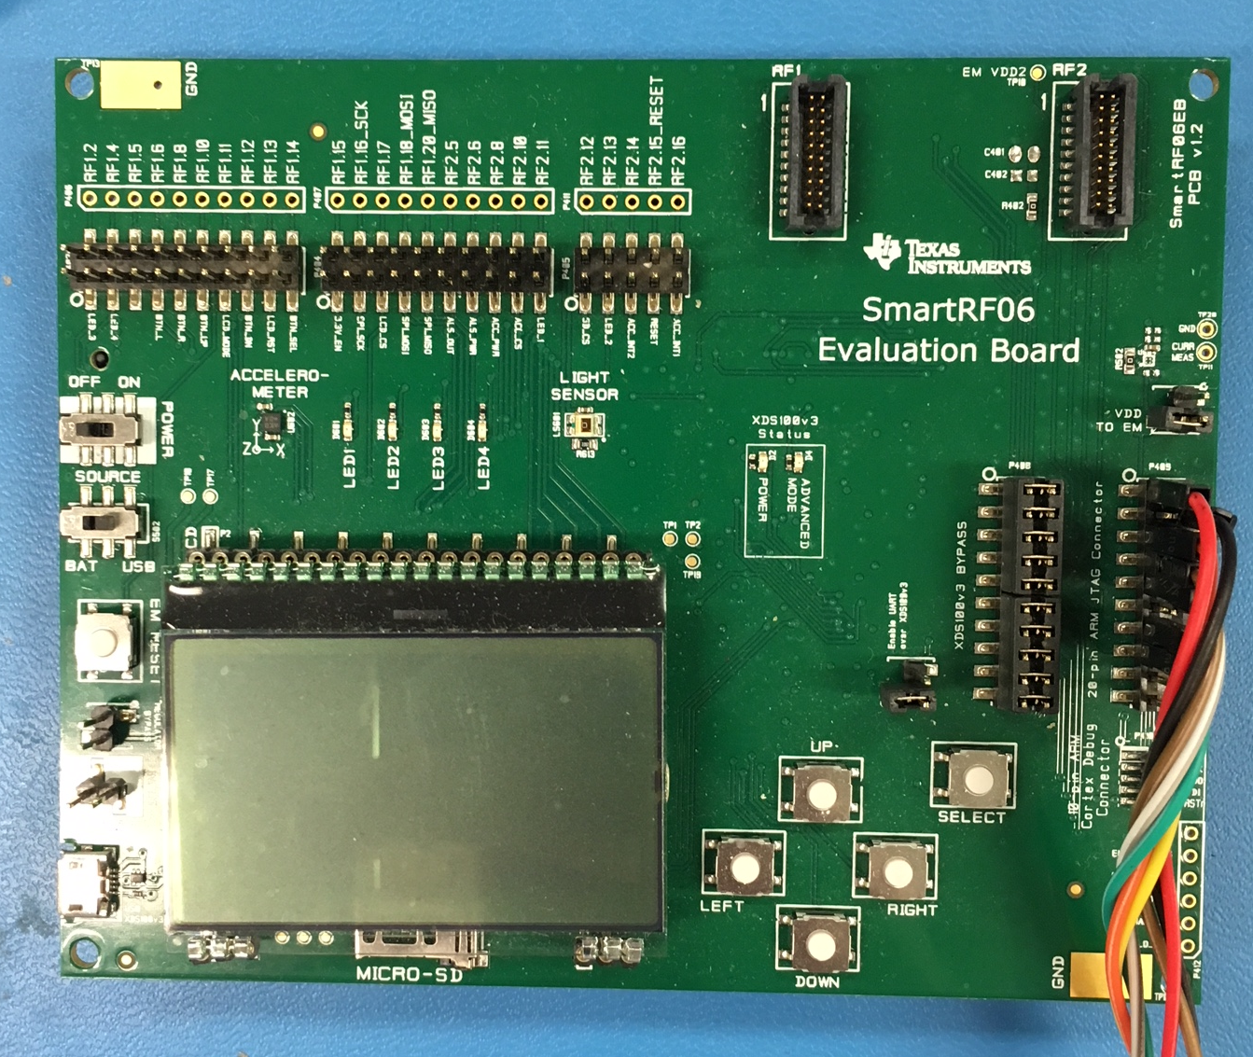

The ARM JTAG connectors should already be hooked-up according to the following picture:

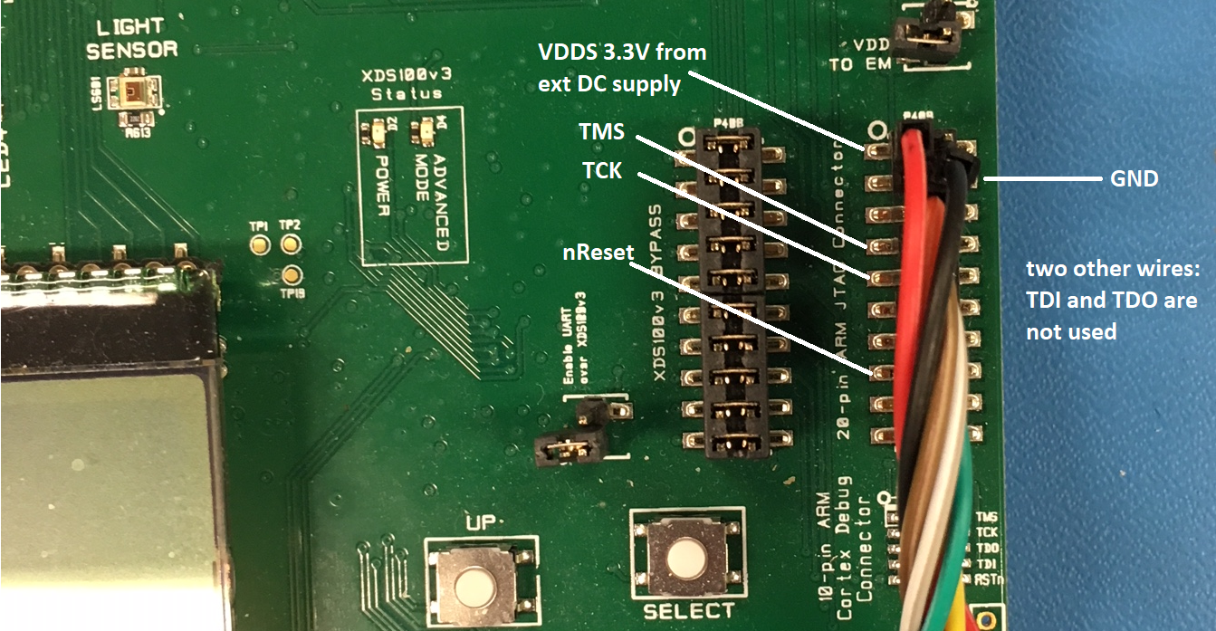

### Connections

Checklist:

* A USB Micro should be plugged between the SmartRf06 EB to the computer running Flash Programmer studio.
* Another External supply should provide 3.3V and GND to the positive and negative rails on the white breadboard.
* The JTAG VDDS/GND on the SmartRF06 EB and the VDDS/ GND of the BLE_Sensor should be common nodes.
* Do not leave battery in socket. Please remove it before proceeding.
* Make sure the Source is set to USB as shown below:

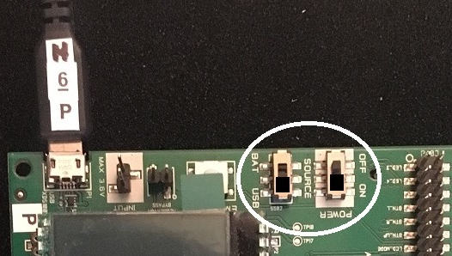

### Power-up

When all the connections are complete:

1. Turn-on the external 3.3V to the common VDDS and GND rails (breadboard + Sensor + JTAG)
2. Turn the Power Switch of the SmartRF06 board ON

When the Power is turned ON the POWER LED (D2) should be lit bright green as shown below:

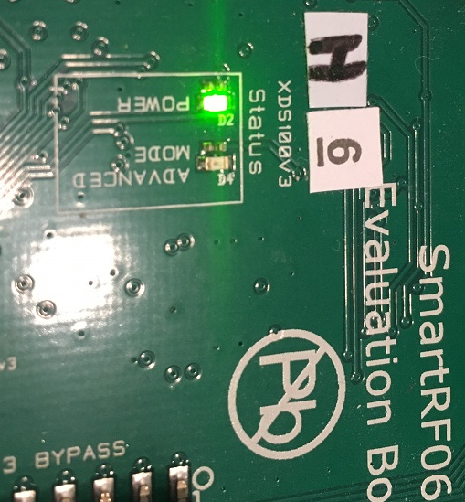

Note: If you see the POWER LED (D2) Bright Green and the ADVANCED LED (D4) Dim Red as shown below, this means there is a problem with the Power Supply to the system. Do not continue until this is fixed.

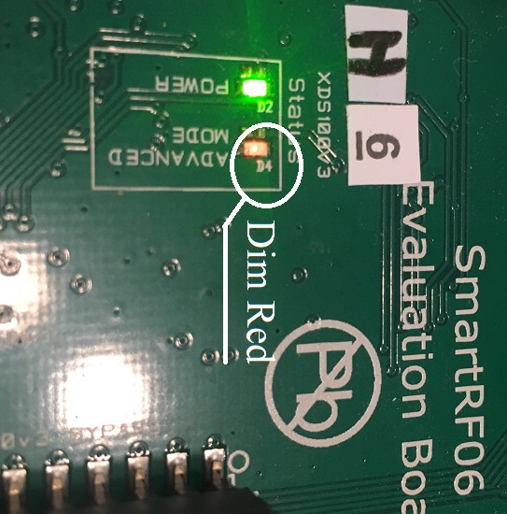

To solve this problem, turn OFF the SmartRF06 Eval Board and Verify that the supply is:

* Set to 3.3V,
* GND and VDDS are connected to the Sensor wires, and
* GND and VDDS are also connected to the SmartRF06 JTAG pins from the breadboard rails as well as to the Sensor
* Make sure battery is NOT in the socket (REMOVE GENTLY---FRAGILE)

## Run Flash Programmer 2 software

* Choose the *Flash Programmer 2* from the Start Menu
* 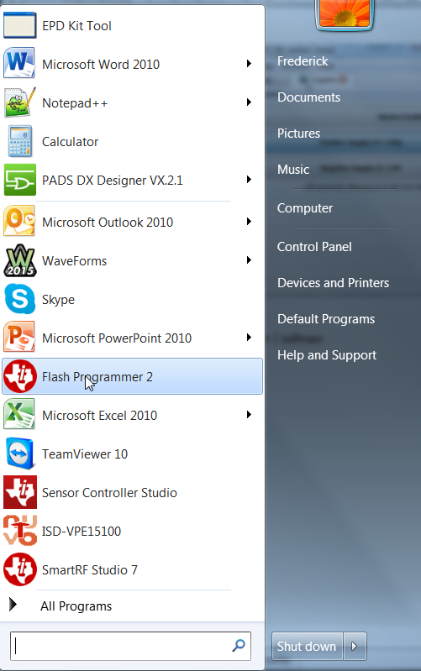

1. In the Flash Programmer Studio 2 window, make sure the CC2650 device appears and click on it once.

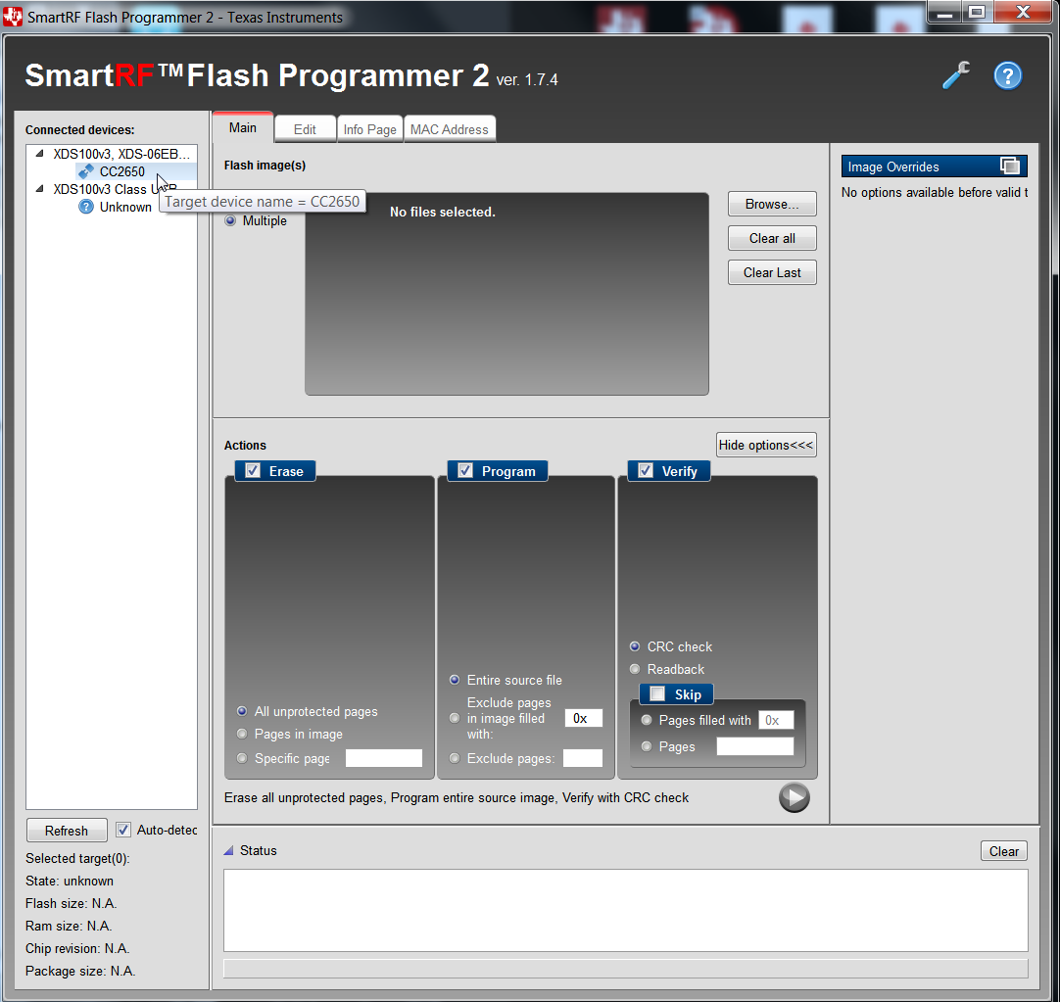

If the product ID (CC2650) does not appear, this means EB2 power or JTAG wires are not properly connected, OR MCU is damaged. Close power supplies, check pins and possible breadboard connection faults and turn the Power ON again.

1. Select the hex files by pressing Browse, then go to the Hex Files folder provided by Innotime and choose both files to upload to the CC2650, as shown below:

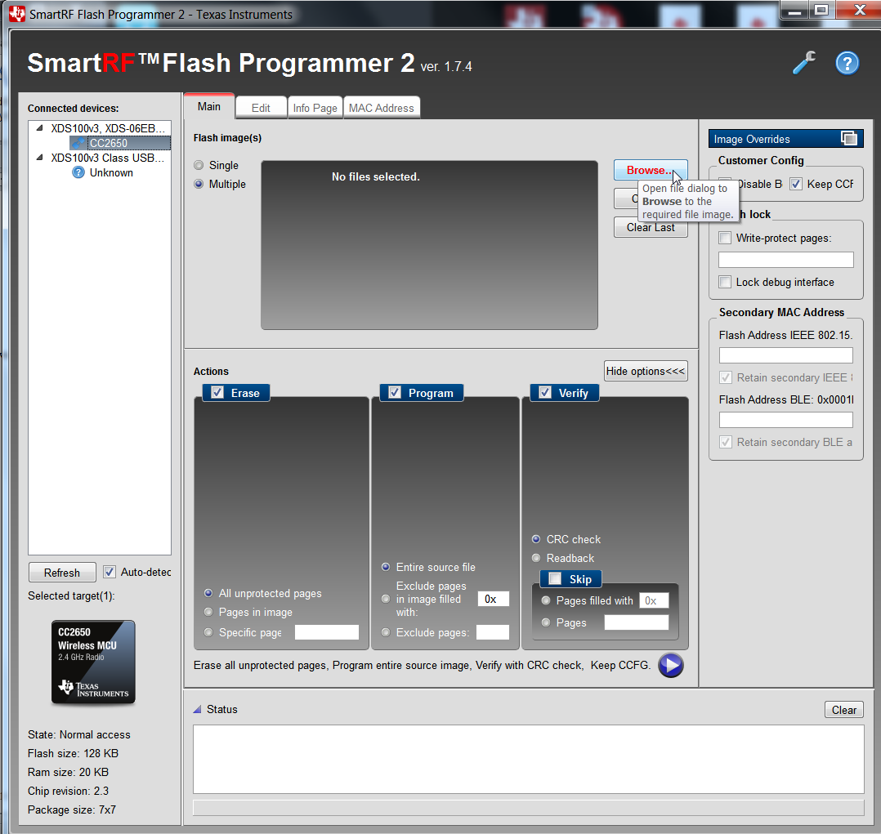

The binary (hex) files can be found here:

*\D8 submit\2_Reference_Designs\BLE_Beacon_Sensor\5_Firmware\fw_binary_20180215*

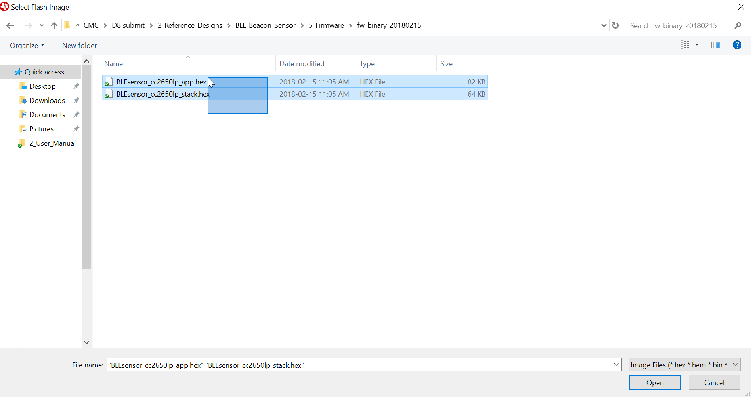

Also make sure that:

* only these two .hex files are checked in the main window
* that the Erase, Program, and Verify options are checked as shown in screenshots

Now proceed to the next step.

1. Re-press the CC2650 icon in the connected device window, then press Start  to Program the MCU.

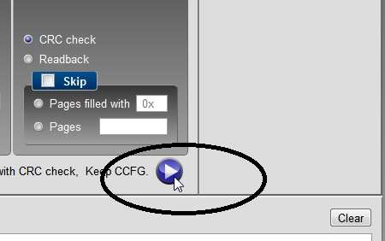

You should see a progress window below the page:

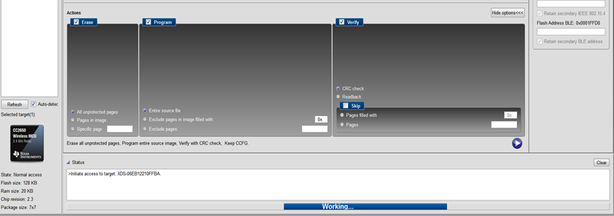

During Programming, the SmartRF06 EB lights-up the POWER LED (D2) Bright Green and the ADVANCED LED (D4) Bright Red as shown below. This is a good indicator and it means everything is OK.

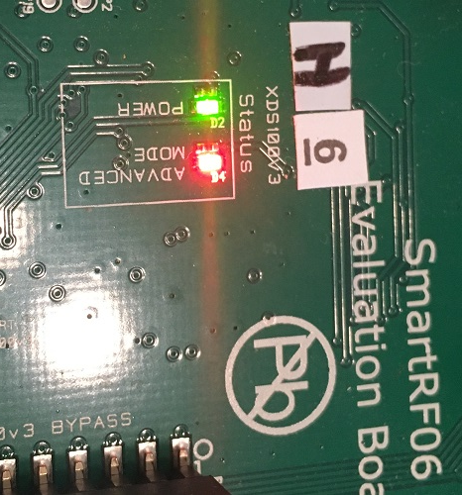

Once programming is successful, a Green progress bar should indicate “*Success!”* at the bottom of the progress window:

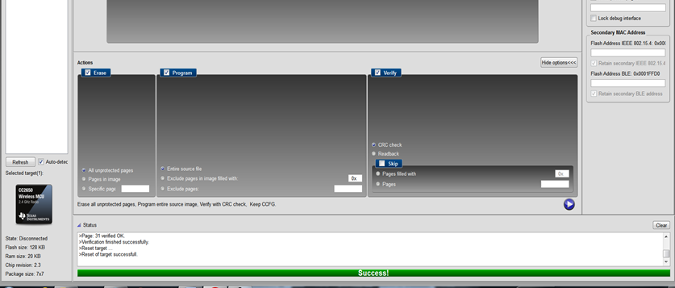

1. All Power supplies can now be Turned OFF and the sensor should be disconnected from the JTAG and supply wiring.

# Running the BLE_Sensor_Node

The sensor is now ready to be used:

1. Place battery in the socket,
2. Check active LED. The sensor’s white Active LED should appear. This will last for ~5 seconds with the previous FW but we extended it to 15 seconds on the most recent release (fw_binary_20180215).
3. Download and install the Android App. The Android app can be found in the App folder. Make sure to set the Scan Setting to a long period so as to not have to re-scan for the beacon all the time.
4. Activate. The white LED on the Sensor should be OFF. When shaken above a programmed threshold, the light will come on, the MCU will be activated and will send out a beacon containing temperature, luminosity-LUX data to the phone. The app will also display signal strength.

1. When the sensor stops the on-board white LED will turn off and the Android App will change to a darker color.